|  |
| --- |
|  |



**17 May 2013** **The Weekly Bulletin of Rotary Club of Kathmandu Mid-Town** **Bc-17.5/012-13**

**District : 3292 Web: www.rotarymidtown.org.np Club Id : 26776**

**MAY : Month Without Theme**

**Except July and May, all other months of a Rotary Year carry a specific theme.**

Friday, 10 May:

Rtn Colin Holmes, Program abd Project Development Officer, USAID, was

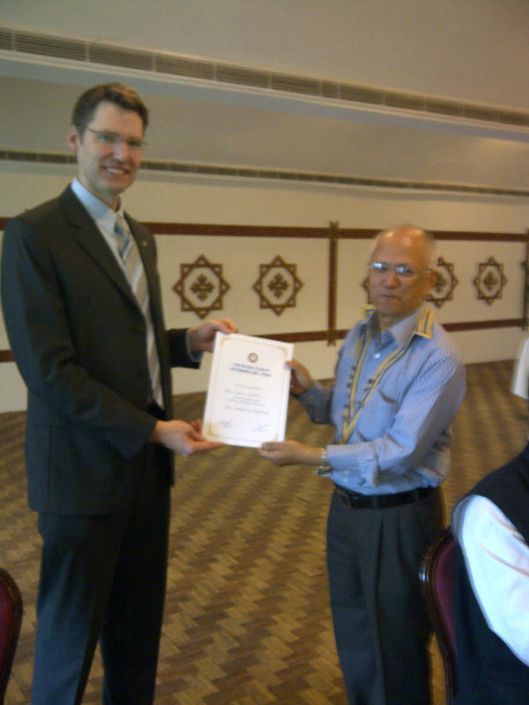

our Guest Speaker who provided an interesting talk On The Pursuit of

Happiness.

Happiness can be defined as a 'state of well-being or contentment'

(Merriam-Webster) or how much one likes the life one leads (World

Database on Happiness).  The consensus of those who conduct experiments

on happiness appears to be that happiness is a function of 1) one's natural

set point - which doesn't change much in life, 2) the conditions of your

life - some of which you can change, others you cannot, and 3) the

voluntary actions that you do. The voluntary actions which are proven to

affect your overall level happiness are varied, but a few powerful ones are

meditation, cognitive therapy and medication. Several very important

components of happiness are the connection one feels to one's work, the

quality and quantity of one's relationships, a connection to something

larger than oneself and the extent to which one is living according to one's

values.  In conclusion, we all can play a role in determining our own level of happiness. But we must know in this pursuit that happiness is not something we can acquire directly, we must get the conditions right, and then wait. Finally, happiness is about the journey, not the destination. So be sure to enjoy your life today!

# Weekly Meetings and Programs :

|  |  |  |
| --- | --- | --- |
| Date | Program/Speaker | Program/Topics of Presentation |
| 17 May 2013 | Dr. Bahi Kaji Tiwari, | District Commissioner |
| 24 May 2013 | Brendan Thomson | Calendrics and the Gregorian calendar |

Friday, 17 May:

Dr. Bahi Kaji Tiwari, District Commissioner, will be our Guest Speaker for the day. Dr Tiwari did his PhD from Kaiser Launten University, Germany on “55 window palace in Bhaktpur, an example of Nepalese Architecture Conservation." He has been working since last seven years as the District Commissioner in Kathmandu Valley Development Authority. He will be talking on urban development and Kathmandu Metropolitan Ciity.

**Harnessing the sun's power to cook:**

Rotarian Allart Ligtenberg spends three months abroad every year, telling anyone who will listen about solar cooking.

Solar cookers use reflective materials such as glass, mirrors, or aluminum foil to concentrate sunlight and convert it into heat for cooking.

Ligtenberg, a member of the Rotary Club of Los Altos, California, USA, was sold on the virtues of the devices more than three decades ago after his company, Hewlett-Packard, sent him to India in 1979. An avid hiker, he spent time trekking through the mountains of Nepal and was spellbound by the country’s beauty, but also troubled by its poverty.

Back home, he saw a newspaper ad for solar cooker blueprints. He sent the company a US$10 check and built the cooker, which he still uses in the yard of his California home.

Power for good

Ligtenberg realized that if the people of Nepal could harness the sun’s power for cooking and water purification, they might be able to alleviate some of their health, environmental, and energy problems. Women wouldn’t have to walk far from home, spending valuable time and risking attack, to find wood for fuel. Deforestation would decrease. Vegetables and fruits could be dried, reducing spoilage. Water could be pasteurized, killing bacteria.

After retiring in 1992, he devoted himself to the cause. Chair of the District 5170 Water, Hunger, and Solar Resource Group, he has met with dozens of service groups, media outlets, universities, and tourism industry representatives.

“You have to find local champions for your cause,” he says. “I can’t be there all year. I’m like a farmer. I plant seeds and hope they blossom into something big. ”

Ligtenberg doesn’t show up to the meetings empty-handed: He always carries along a solar cooker of his own design so he can demonstrate how one works.

“In 20 minutes, I can make soup,” he says.

Securing funding

He then shows pictures of larger cookers and tells people how they can get help with assembly and maintenance after he leaves. He works with local nongovernmental organizations, many of whom he connected with after joining Rotary.

“Some NGOs have timelines or don’t want to try something new,” says Ligtenberg, reflecting on the challenges he’s faced. “Some of them want money under the table. And it’s hard to get governments officially involved.”

During the nine months he spends back home, Ligtenberg works to secure funding for projects, including Rotary Foundation Matching Grants, and to develop other efforts, such as starting carpentry and metalworking classes in Nepal, distributing devices that can purify water without boiling, and getting solar cookers into developing nations like Afghanistan, Indonesia, Peru, Bolivia, Mexico, Mongolia, and Haiti.

“This simple technology solves problems,” he says, "one village at a time."

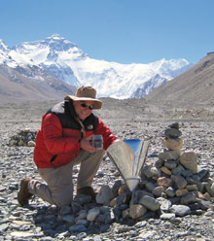 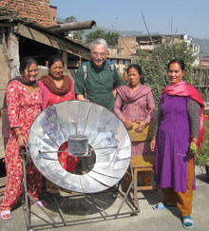

Allart Ligtenberg shows how to prepare lunch in a backpack solar cooker of his own invention at Everest North Base Camp. And Ligtenberg with women from Balambu, near Kathmandu, Nepal

*Source:* Patty Lamberti/Rotary International News

**2013 IAF Emerging Space Leaders Grant Programme:**

The International Astronautical Federation (IAF), Paris, has selected recently our Rtr President Kishor Acharya as one of the 12 young people to participate in the 2013 IAF Emerging Space Leaders Grant Programme and attend the 64th International Astronautical Congress in Beijing, China from 23 to 27 September 2013. Rtr Kishor was selecged from among 130 students and young professionals from 38 countries who participated in the competition.

**Congratulations**

***to Rtr Kishor Acharya for his success and achievement !***

**Committee Chairpersons' Column:**

**???**

**Past Presidents' Column:**

**???**

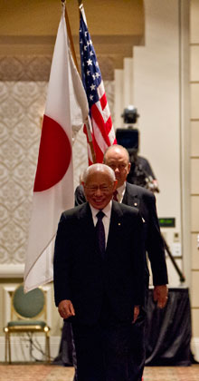

The bigger Rotary is, the stronger we are. But we cannot see a larger membership as the only

goal. If we are bringing new people into Rotary only for the purpose of having more members, this will not make Rotary stronger. We will make Rotary stronger when we bring in people

who will not just join Rotary but become Rotarians.

**RI President Sakuji Tanaka**

Searching Happiness ?



**A Thought for the Day:**

***The most erroneous stories are those we think we know best, and***

***therefore we never scrutinize or question.***

*courtesy:* Rtn Dr Isabella C Bassingana Khadka

**Great Quotes:**

***Creativity is allowing yourself to make mistakes.***

***Design is knowing which ones to keep.***

NB: Send any informations/photos that may be of interest to the Club or Rotarians in general to

BC Editor: RR Shrestha email: rryesrr@gmail.com

## 17 May 2013 The Weekly Bulletin of Rotary Club of Kathmandu Mid-Town bc-17.5/012-13